Antifreeze/Battery Fluids Refractometer ADD501A
Operation Manual
ADD501A are designed to test the concentration of the battery fluids, antifreeze liquid and cleaning fluids. With the indication of the percentage you may know at which temperature the fluid will be frozen for both propylene glycol and ethylene glycol. It can also be used for checking the strength of electrolyte solution batteries. Remarks: in the following firms, E, P, B and C respectively refer to ethylene Glycol, ropylene Glycol, Battery and Cleaning Fluid

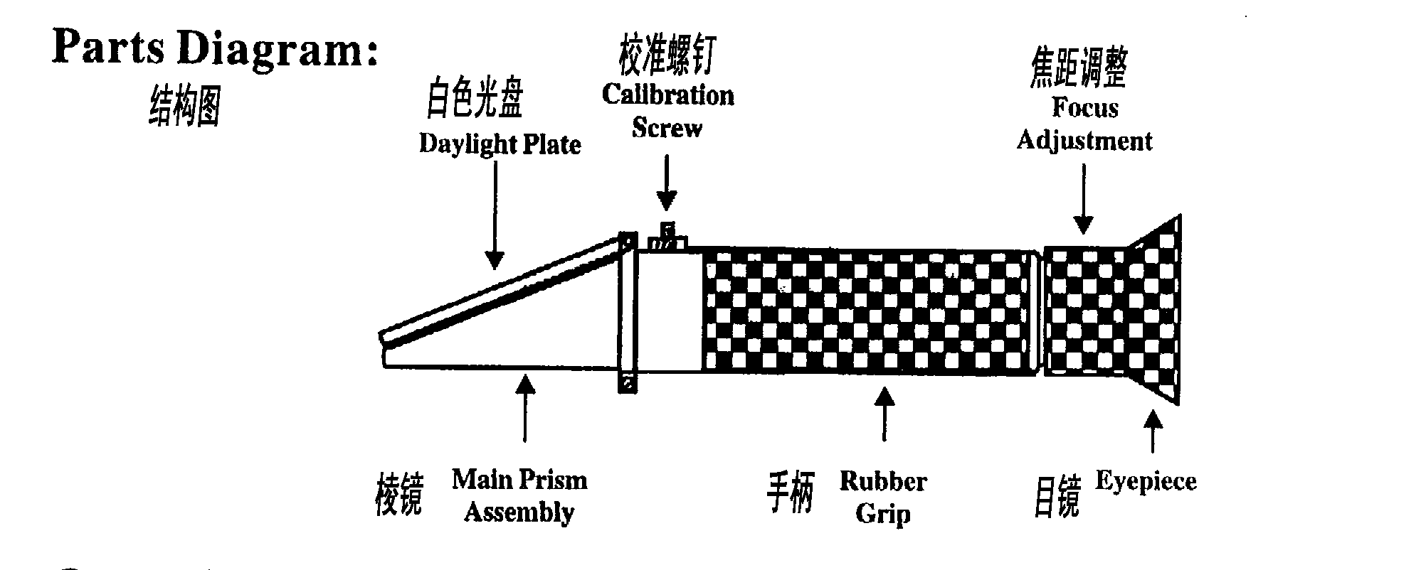

Step 1.
Flip open the daylight plate on top of the Refractometer. Place 2-3 drops of the specimen on the main prism. Close the daylight plate so the sample spreads across the entire surface of the prism without air bubbles or dry spots.

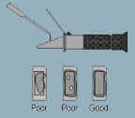

Step 2.
Hold the refractometer (daylight plate) in the direction of a light source and look into the eyepiece. You will see a circular field with graduations down the center (you may have to focus the eyepiece to clearly see the graduations). The upper portion of the field should be blue, while the lower portion should be white

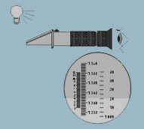

Step 3.
Take the reading where the boundary line of the blue and white intersect at the graduated sale. The scale will provide a direct reading of refractive index . Clean the prism carefully using a damp soft cloth. DO NOT immerse refractometer in water. Please read the Operation Manual carefully before using the Refractometer.
